2025-2026 SOUTHERN SOUND SERIES
SAILING INSTRUCTIONS

Notation: ‘[DP]’ in a rule in the sailing instructions (SIs) or notice of race (NoR) means that the penalty for a breach of that rule may, at the discretion of the protest committee, be less than disqualification. The notation ‘[NP]’ in a rule of the SIs or NoR means that a boat may not protest another boat for breaking that rule. This changes RRS 60.1(a).

RULES
  - The event is governed by the rules as defined in The Racing Rules of Sailing.
  - The following rules are changed:
    - RRS 60.4(a)(2) is changed as follows: “if it is from a boat that alleges a breach of a rule of Part 2 or rule 31, and it is from a boat that was not involved in and did not see the incident, or”
    - RRS V1 and V2 are in effect.
    - V2 is modified to remove the last sentence, (Starting at “However…)
    - RRS T2 is changed. “will” replaced by “may” in the first sentence.
    - Additional rule changes appear elsewhere in these Sailing Instructions.
  - US Sailing Prescriptions apply: https://bit.ly/2025-Prescriptions
  - US Sailing Safety Equipment Requirements 2025 (https://bit.ly/USSailingSER) as amended by these SIs.
  - All boats must carry a working VHF radio and monitor Channel 72.
  - In case of conflict, these Sailing Instructions take precedence over the NOR. (This changes RRS 63.5 (c).
  - Boats racing under PHRF or ORC handicaps will be scored DNC without a protest or hearing if they do not have a valid handicap. This changes RRS A5.
  - Non-PHRF Cruising and Commodore Class boats are subject to Non-PHRF Classes Rules; see Appendix A below.
  - All competitors must follow the USCG VTS Navigation Rules and COLREGs. Between racing boats, RRS takes precedence over COLREGs.
  - TRAFFIC SEPARATION LANES:
Race participants shall monitor VHF Channel 14 in addition to RC Communication Channel. All skippers and crews are expected to be fully familiar with and comply with Rule 10 of the International Regulations for Preventing Collisions at Sea which states: Skippers are reminded that vessels under sail DO NOT always have the right of way over power driven vessels. “…a sailing vessel shall not impede the safe passage of a power-driven vessel following a traffic lane.” Race participants are expected to yield to vessels in the traffic lane even to the detriment of competitive position. If a race participant needs to contact Vessel Traffic Service (VTS) they should use VHF Channel 14. Interference with ferry or traffic lane power driven vessels may result in a boat being disqualified. If a boat fails to respond to a hail from a vessel or Vessel Traffic Services (VTS), the Race Committee may score the boat DSQ without a hearing. This changes RRS A5.1.
  - FERRY BOAT CLEARANCE:
Ferries travel between the north end of Vashon Island and Fauntleroy, Seattle and Bremerton; between Seattle and Bainbridge Island; and between the south end of Vashon Island and Point Defiance. All yachts must maintain a minimum 500 – yard distance from any ferry boat, which has the right of way at all times, regardless of its location and speed. Interference with ferry traffic may result in a boat being disqualified. All boats shall stay clear of the Point Defiance ferry landing area before, during, and after the Vashon Island Race.

CHANGES TO SAILING INSTRUCTIONS
  - Any change to the sailing instructions will be posted on the series website (ssseries.org) and will be posted at the host club for the affected race before 2000 hours on the day before it will take effect.

COMMUNICATION BETWEEN RC AND COMPETITORS
  - [DP] The race committee intends to monitor and communicate with competitors via VHF 72. VHF communications by competitors on this channel shall be limited to check-in, emergencies, retirement from racing or to comply with other RRS or SIs such as SI informing of protest
  - The Race Committee’s cell phone numbers are published in the Notice of Race and may be used during the race as an alternative to VHF channel 72.
  - In the event of a man overboard (MOB), the boat shall activate the boats VHF distress DFC button if so equipped, broadcast an MOB distress call on VHF Channels 16 and 72, in that order, and contact the race committee via VHF Channel 72, and if unable via radio then via RC phone listed for the race. All racing vessels shall monitor VHF 16 and 72 to enable notification of a MOB and assist if possible.

SIGNALS MADE ASHORE
  - Location of signals made ashore is specified in the Individual Race Sailing Instructions below in SI 8.
  - AP flag ashore: “1 minute” is replaced with “not less than 60 minutes.” (This changes the RRS-race signal AP.)

SCHEDULE OF RACES
  - There will be one distance race each day, on the dates published in the NOR.
  - Starting Schedule:
    - Cruising Classes (PHRF and Non-PHRF, NFS and Commodore Class) scheduled warning is 0925
    - The first of the remaining PHRF classes scheduled warning is 0955
    - Slower PHRF classes will start first (reverse starts – highest PHRF class # first).
    - The ORC class will follow the last PHRF class
    - The start of one class may be the warning of the following class.
    - Vessels shall assume each class will start separately. Race start sequences and classes will attempt to be announced over VHF 72.

6. CLASSES
6.1 Class breaks will be determined Wednesday evening before the Vashon Island Race based on racers registered PHRF or ORC ratings. Class break assignments will be posted the Thursday before the Winter Vashon Race and to the SSS website as updated for that year’s SSS Sailing Instructions.
6.2 Class Flags will be posted with the class breaks.
6.3 Class breaks for the PHRF classes are as follows:

2025 – 26 PHRF Classes
Class 1: Multi Hulls class
PHRF2 – 0 to 60
PHRF3 – 61 to 75
PHRF4 – 76 to 93
PHRF5 – 94 to 119
PHRF6 – 120 to 144
PHRF7 - 145 and up
PHRF9CruisingNFS
PHRF10CommodoreFS

Non-PHRF Cruising Classes
NonPHRFCruisingNFS
NonPHRFCommodoreFS

ORC Class
All boats with active 2025 ORC certificates for the Winter Vashon, Duwamish Head, and Toliva Shoal races and 2026 ORC certificates for the Islands Race.
6.4 Class Flags
Class flags for each class will be the letter flag or numerical pennant flag for the class.
PHRF and non-PHRF Cruising NFS and Commodore FS Classes "C" Flag
PHRF Classes respective number pennant
Class1 – multi hulls "1" pennant
ORC Class "0 (zero)" pennant
One Design class designed flag or agreed upon letter flag

FINISHING AFTER DARK
Boats finishing in darkness or reduced visibility shall illuminate their sail numbers with a light and hail the RC as they finish with their sail number and boat name.

INDIVIDUAL RACE SAILING INSTRUCTIONS

Winter Vashon
Approximate distance 30.7 nm.
NOTE: Information on pre and post-race activities will be posted on the Tacoma Yacht Club web site https//www.tacomayachtclub.org.
    - Course
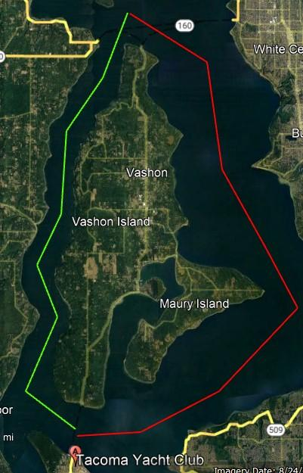
      - Race starting and ending near the Tacoma Yacht Club racing clockwise around Vashon Island.

      - The start will be between the an Orange Flag on the RC Signal Boat and the course side of an inflatable mark to the north, leaving the RC Signal Boat to PORT
      - The finish will be between a Blue flag on the North-East end of the TYC dock and the course side of an inflatable mark off shore.
      - An orange or yellow inflatable mark will be anchored as a limiting mark approximately ½ mile North of the ferry dock at the North end of Vashon Island (on Allen Shoal). This mark shall be left to STARBOARD.
      - A North End Race Committee boat may be anchored approximately 200 yards north of the limiting mark. If the North End Committee boat is on station, all boats must pass between the committee boat and the limiting mark.
      - If conditions prevent anchoring the inflatable mark, it may be placed on the bow of the North End RC boat, in which case the entire boat should be treated as the limiting mark. This mark shall be left to STARBOARD. (Please be mindful that the North End RC boat is provided by a volunteer and effort should be made to avoid colliding with the North End RC boat.)
    - SHORTENED COURSE
The race committee may shorten the course at the limiting mark. If the RC was unable to set a mark (SI 8.1.1.4) the finish line is between the RC and the southern tip of Blake Island. This changes RRS 32.2

Duwamish Head
Approximate distance 30.8 nm.
NOTE: Information on pre and post-race activities will be posted on the Three Tree Point Yacht Club web site https://www.ttpyc.org
    - COURSE
      - Race starting and ending at Des Moines Marina going around Duwamish Head Light and Blakely Rock, leaving both to port.
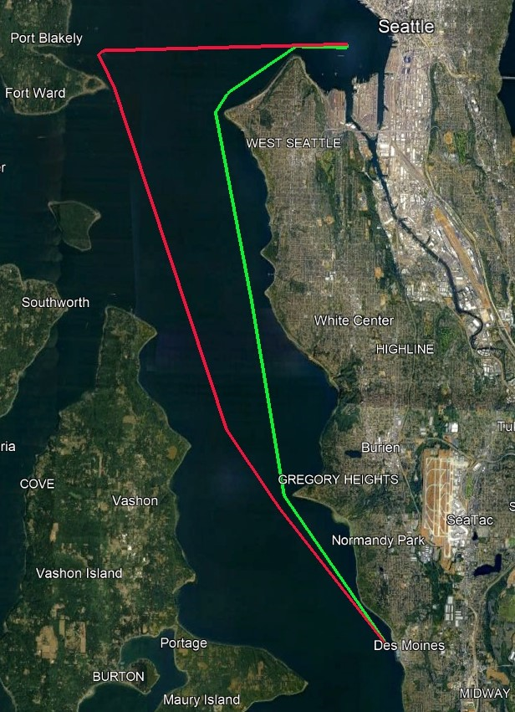
      - The start will be between an Orange Flag on the end of the Des Moines fishing pier and the course side of an Orange inflatable mark offshore, leaving the mark to PORT.

      - The finish line is between a Blue flag on the end of the Des Moines fishing pier and the course side of an Orange inflatable mark offshore.
        - If the finish mark is missing, boats will finish by crossing a line between the RC flag at the end of the fishing pier to the Point Robinson lighthouse. Finishers should pass within approximately 10 boat lengths from the end of the fishing pier. The Race Committee will broadcast this modification to the finish line on VHF 72. This modifies the US Sailing Prescription to RRS 34.
      - The green lighted navigation buoy to the south of the Des Moines Fishing pier is a limiting mark. Boats will not sail between it and the pier while starting or finishing.
    - SHORTENED COURSE:
The RC may shorten course in accordance with RRS 32.2 at either Duwamish Head Light dolphin or at the north side of Blakeley Rock. The course distances are approximately 13.5 nm and 18.8 nm respectively.

Toliva Shoal
Approximate distance 38.4 nm
NOTE: Information on pre and post-race activities will be posted on the Olympia Yacht Club and South Sound Sailing Society web sites: https://www.ssssclub.com & https://www.theolympiayachtclub.com
    - COURSE:
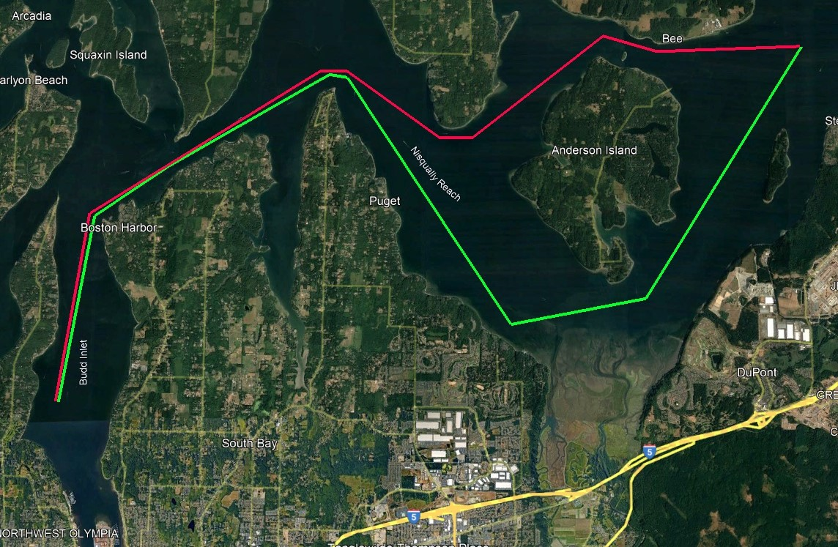
      - Start between the Orange flag on Race Committee Signal Boat and the course side of the east marker of the Olympia Shoal in a northerly direction.

      - In the following order leave Dofflemyer Point and Johnson Point to STARBOARD; then the government mark #3 off Nisqually Delta, the Toliva Shoal buoy, Eagle Island, the government mark #1 at the west end of Balch Passage, Johnson Point, and Dofflemyer Point to PORT.
      - Finish between the Blue flag on the RC Signal Boat and the course side of the east marker of the Olympia Shoal.
    - SHORTENED COURSE:
The RC may shorten course in accordance with RRS 32.2 at any of the following points Dofflemyer Point (3.13 and 34.6 nm) or Johnson Point (7.65 and 30.5 nm) departing or returning respectively, the government mark #3 off Nisqually Delta (12.5 nm), the Toliva Shoal buoy (21.1 nm), the government mark #1 at the west end of Balch Passage (25.1 nm).

Islands Race
Approximate distance 35.2 nm.
    - COURSE:
      - In the vicinity immediately west of the Browns Point Light House. The starting line is between the CYCT RC signal boat flying an Orange flag and the course side of a temporary orange tetrahedron pin.
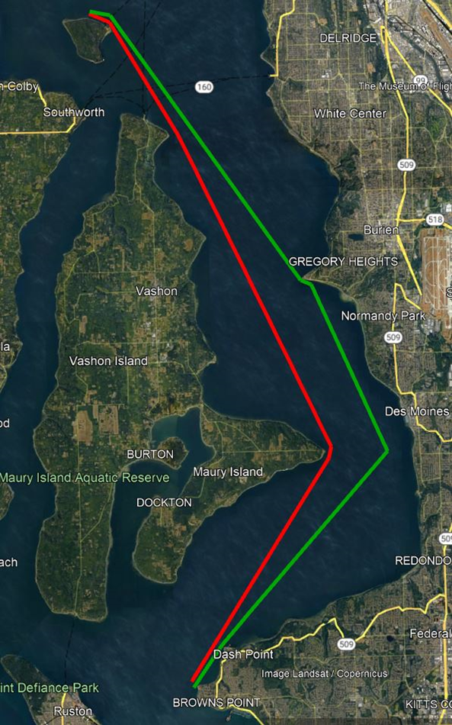

7.4.1.2 Proceed north to Three Tree Point rounding the TTPYC “C” mark, a permanent white 6” cylinder rising 8 feet above the water located approximately 1,000 feet SE of the Three Tree Point Light, to PORT. Proceed northwesterly to the turn mark located approximately four tenths of a mile north of Blake Island, a temporary orange or yellow inflatable tetrahedron mark, and round to PORT.
7.4.1.3 Finish west of Browns Point between the Blue flag on CYCT RC boat and the course side of the temporary orange tetrahedron pin.
7.4.2 SHORTENED COURSE:
The RC will announce shortening of the course on VHF Channel 72. The RC may shorten course in accordance with RRS 32.2 at the TTPYC “C” mark, or the Blake Island turning mark. The course distances are approximately 10 nm and 17.5 nm respectively.

TIME LIMIT
The time limit for all boats is 13 hours from her start. Boats not finishing within 13 hours shall be scored DNF. This changes RRS 35.

SCORING
  - PHRF class time corrections will be calculated Time-On-Distance
  - ORC class time corrections will be calculated using Time-on-Time (APH ToT)
    - ORC 5 Band Ratings for wind may be used.
    - The RC may choose the windband rating based on their best available information for the wind conditions, generally as listed below:
Low: 0 to 8 kts – avg.= 4,
Low/Medium: 6 to 12 kts – avg. = 9,
Medium: 8 to 16 kts – avg. = 12,
Medium/high: 12 to 20 kts – Avg. = 16,
High: 16+ kts – avg. 20+
    - The RC will announce the windband rating if used before or within 15 minutes of the first ORC boat finishing on VHF.
    - The Race Committee's decision on which windband rating to use, if used, is final and not subject to redress. This changes RRS 61.4(b)(1).
  - If all 4 races are scored, a boat’s worse score, other than DNE, will be excluded.
  - Boats scored DNF, RET, OCS or DSQ will be scored the number of boats in their class that sailed the course and finished plus 1. This changes RRS A5.2
  - Boats scored DNC or DNS will de scored the number of boats in their class that sail the course and finished plus 2 This changes RRS A5.2
  - Series Ties–A tie shall be broken in favor of the boat with the best excluded score (throw-out). This changes RRS A8. If a tie remains, then Rule A8.1 and Rule A8.2 will be applied.

CHECK-IN AND RETIRING
  - [DP][NP] Boats must check in with the RC Signal Boat by sailing by and hailing or on VHF 72 prior to 0925 for Cruising Classes or 0955 for all other classes. Your hail (in person or over VHF) must be acknowledged to satisfy this SI.
  - [DP][NP] A boat that retires while racing must notify the race committee on VHF Ch 72 and receive an acknowledgment, or by calling the telephone number of the Race Organizing Authority for the race listed on the race sponsor’s web page and speaking to a race official or leaving a voice message. A boat breaking this rule shall be penalized with the score DNE (Disqualification that is not excludable). In the past, failing to inform the race committee of a boat’s retirement has led to race committee and/or chase boat searches and have at times led to Coast Guard searches.

PROTESTS
  - A boat intending to protest or request redress as a result of an incident on the race course shall inform the Race Committee of her intent using VHF, Hail, or telephone within 10 minutes of her finish.
  - Protests MUST be emailed AND ACKNOWLEDGED within 48 hours of the boat’s full course time limit.
  - An email address for each race is posted in the Notice of Race.
  - The Protest Committee will make every effort to hear protests the Thursday following the event and boats should be prepared for a hearing at that time.
  - Series request for Redress. In the event a request for redress is lodged pertaining to the Series, as opposed to an individual race, a redress committee consisting of one member each from TYC, TTPYC, SSS/OYC, and GHYC will be appointed to hear the request. The time limit for receipt of a series request for redress is two weeks from the date of the last series race. Series protests may be mailed to: Southern Sound Series Protest Committee, PO Box 1102, Olympia, WA 98507

SAFETY REGULATIONS
  - 2025 SERs may be reviewed at https://www.ussailing.org/competition/offshore/safety-information/ser-world-sailing-special-regulations/
  - Boats must comply with the equipment requirements of US Sailing US Safety Equipment Requirements (USSER) category “Nearshore”. The following additions apply to the SER Nearshore Regulations for this series:
  - SER Coastal 2.7.2 Mechanical Propulsion and further as required in 2025 PHRF Rules (applies to all boats, not just PHRF boats)
Chapter II C:
10: If Inboard Auxiliary Engine: Has folding or feathering propeller, propulsion assembly sufficient to drive boat at 90% of "hull speed" in flat water.
12: If Outboard Auxiliary Engine: Installed on permanent mounting, permanently connected to securely fastened fuel tanks, completely retracted but ready for instant immersion, propulsion assembly sufficient to drive the boat at 90% of “hull speed” in flat water.
  - SER Coastal 3.26 Radar Reflectors
  - Any single or double-handed crews must wear a PFD at all times.
  - All participants are advised to wear PFDs and all participants shall wear PFDs when the race committee flies the Yankee Flag (Y flag) prior to the race start. The Racing Rules of Sailing 1.2, 27.1, and 40.
  - The race committee reserves the right to cancel or delay racing due to unsafe conditions. However, the fact that the race committee has not canceled a race, nor the fact that other boats are still racing, should not be interpreted to mean that conditions are necessarily safe for all vessels. It is the responsibility of the individual yacht to decide when conditions are unsafe for their vessel and to take appropriate safety measures.
  - A boat may be inspected at any time by a race committee to ensure compliance with the USSA SERs Coastal as amended for the series.
  - A skipper shall “certify” that the boat when registering for a series race complies with the safety requirements for the series.

USE OF MOTORS
  - Motors shall not be used for propulsion while a boat is racing (as defined in the RRS) unless for one of the exceptions listed below. Allowable exceptions where motor use is allowed include:
    - When following RRS 1 (Helping Those in Danger).
    - To move out of the way of commercial vessel traffic.
    - To move another boat or herself off of a grounding.
    - To gain steerage to prevent a boat from being pushed by the wind or currents into an otherwise certain and immediate grounding.
    - To get a boat to the starting area for the first time that morning or to prevent a boat from being pushed by the wind or the currents into the Race Committee boat at the start. In this case, the boat shall not start until four minutes after her motor has been turned off.
    - To charge batteries or for other electrical uses or heat, as long as the engine is not placed in gear.
  - In no case should the use of the motor have reduced the distance a boat will need to sail to finish the course, nor should the use of the motor place the boat in a more favorable position relative to the prevailing wind or current conditions or her competitors.
  - In the event of any use of the motor for propulsion while racing, the boat’s skipper shall report by radio to the race committee the fact that the motor was run while she was racing. The boat’s skipper shall also file a written report with the race committee promptly after they have finished the race (within the protest time limit). This report shall include the GPS coordinates and the time when the motor was started and when the motor was turned off with a full description of the circumstances and other relevant information (such as, but not limited to, water depth, boat speed and heading, current and wind conditions).
  - If a report is not filed as described above, showing that fair racing was preserved as judged by the exclusive opinion of the race committee, the boat may be protested and disqualified.

AIS BROADCASTING
If a participating vessel has the ability to broadcast AIS, AIS must be broadcasting during all series races.

State of Washington Senate Bill 5371 / Protecting Southern Resident Orcas from Vessels
  - Protecting Orcas
Washington Senate Bill (SB) 5371 governs this event (see the definition Rule (g)). SB5371 states:
Operators of motorized vessels, non-motorized vessels and paddle crafts must stay 1,000 yards (approximately one-half nautical mile) away from southern resident killer whales (SRKW) in all directions. If the SRKW approaches within 400 yards of any vessel, state law requires that the vessel disengages the transmission, luffs sails, or stops paddling (if it is safe to do so) until the animal(s) moves away. Boaters who think they may be closer than 1,000 yards to SRKW, but not within 400 yards, should attempt to navigate out of the path and away from SRKW at a speed of 7 knots or less.
However, for this event the requirements of SB 5371 shall apply to all orca whales; not just SRKW. (c) Boats may be protested for breaking 20.
  - If an orca is seen by the crew of a boat, the boat shall not enter the circular area within 1000 yards of the orca (therefore, that area is an obstruction.); and if the boat is within 400 yards of an orca, she shall, as soon as reasonably possible, luff (or, if motoring before or after racing, disengage her transmission) to slow to the slowest safest speed, which may be to stop, until they are no longer within 1000 yards of any orca.
  - Add to RRS Rule 32.1
(e) if an individual orca or orca pod is found to be in, near, or approaching the race area.
  - Add to RRS Rule 61.4 (b):
(6) reasonable actions she took to comply with SI 16.

APPENDIX A
Non-PHRF CLASS RULES

Non-PHRF Cruising Class-NFS and a Commodore Class-FS will be offered at each race venue. No PHRF rating is required or will be used. Each vessel will be scored where it finishes in its class. These classes will be scored independently and will not be eligible for series overall or team awards.

Non-PHRF Commodore Class boats must comply with PHRF rules and regulations, except that membership in PHRF is not required. Boats may fly such sails as spinnakers, mizzen staysails, streakers, drifters flown from their own temporary stays, etc.

Non-PHRF Cruising Class-NFS boats must comply with PHRF rules and regulations for "No Flying Sails" rating, except that membership in PHRF is not required. This includes, but is not limited to, rules on whisker pole length and the rules listed below.

To be eligible for a "No Flying Sails" rating, boats must use working sails only: attached by their luff to permanent stays or spars. Not less than 90% of the luff length must be attached to the permanent stay or spar with not less than eight (8) snaps or sail track slides distributed evenly along the luff; or, alternately, attachment may be by a luff-rope groove. Only one (1) working sail luff may be attached to each permanent stay or spar.

Non-PHRF Cruising NFS and Commodore FS Classes: Only one sail may be used forward of the main mast on Sloops, Cutters, Yawls, and Ketches unless the yacht is specifically rated for carrying additional sails. When changing jibs, the "up" – hoisted – jib must be fully lowered to the deck before the replacement jib is raised. Before lowering the "up" jib, the replacement jib may be hanked on the forestay, or started in the second head foil groove up to five feet above the deck. The second halyard may be attached before lowering the "up" jib. Jibs may NOT be attached to temporary or detachable stays. NFS ratings exclude such sails as spinnakers, mizzen staysails, streakers, drifters flown from their own temporary stays, etc.

The above was excerpted from Pacific Handicap Racing Fleet of the Northwest PHRF-NW web site, No Flying Sails Rating.

